SAFEGUARDING POLICY

At our club, we strive to provide a safe, enjoyable and inclusive environment for all of our members and staff.
We are committed to working in accordance with statutory responsibilities, government guidance and comply with the best practice and requirements set by the Lawn Tennis Association (LTA) and England Squash and Racketball (ESR).

We aim to ensure that regardless of age, gender, religion or beliefs, ethnicity, disability, sexual orientation or socio-economic background, all children and any adults at risk have a positive and enjoyable experience at our club.
This policy outlines our commitment to safeguarding and protecting all children, young people and any adults at risk from abuse whilst at our club.

Contents
The difference between Safeguarding and Protection | 2
Welfare Officer | 3
Safe Recruitment | 4
Anti-Bullying | 5
Responding to concerns | 5-6
Complaints and feedback | 7
Appendices
- Definitions of abuse | 8-9
- Flowchart for managing allegations against people who work with children and young people | 10
- Safeguarding Concern Form | 11-17
- Additional Support | 18

The difference between Safeguarding and Protection

Safeguarding

It’s about being proactive, raising awareness and putting preventative measures in place.
To help safeguard the members at our club, we:
- Work in accordance with this Safeguarding Policy.
- Work in accordance with out Equality and Diversity Policy.
- Have a designated and trained Welfare Officer.
- Have a clear and transparent complaints procedure.
- Follow the LTA’s and ESR’s Fair Play values of Enjoy.Respect.
- Promote an inclusive and positive ethos.
- Ensure all children are appropriately supervised at our club.
- Consult with the LTA and/or ESR Safeguarding Team for advice and support.
- Ensure employees operate in accordance our code of conduct for working with children.
- Follow LTA and ESR guidance, policies and procedures.

Protection

It’s when abuse, neglect or harm has happened or is likely to happen.
When a child, young person or adult at risk needs protecting at our club, we:
- Follow a clear process for sharing concerns.
- Take immediate action by alerting the LTA/ESR Safeguarding Team.
- May speak with Local Authority Social Care services, police and other agencies.
- Follow guidance set by the LTA and ESR on managing allegations against any members of our staff (paid or voluntary).
- Ensure all our staff and members are suitably protected whilst a statutory investigation is on-going.
- Treat matters confidentially, unless if by not sharing information people could be put at risk of harm.

SAFEGUARDING AND WELFARE OFFICER
NAME
JAN RANDALL
PHONE
07762 336635
EMAIL
jan@lltsc.co.uk
ABOUT ME
My name is Jan Randall and I have been LLTSC’s Safeguarding & Welfare Officer since December 2021. I have been a member for over 10 years and really enjoy my social and team tennis. I work as a counsellor and deal a lot with safeguarding issues at work, both with children and adults. My responsibilities to the club will be to promote and prioritise the safety and well-being of children and adults. It is also to encourage and maintain a culture where members feel able to raise any genuine safeguarding concerns and to know they will be taken seriously.
The safeguarding policy can be found on the club’s website. If you wish to contact me with any questions or concerns please email me at jan@lltsc.co.uk or call 07762 336635

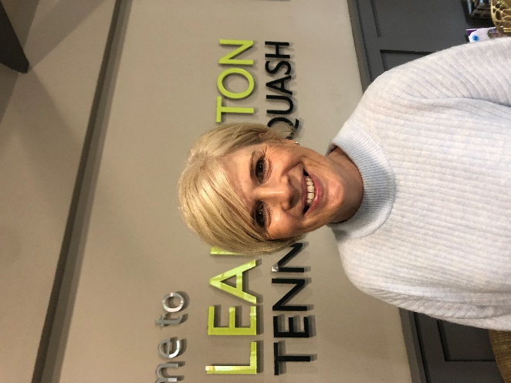

Safe recruitment
When recruiting people (paid or voluntary) to work at our club, we work in accordance with the LTA’s and ESR safe recruitment procedures. The process we follow is outlined below:

Advertise the position, ensuring that the required competencies, responsibilities and qualifications are clearly outlined.

Shortlist the most suitable applications.

Obtain at least two references, with one ideally from the most recent employer.

Interview the shortlisted candidates.

Make a provisional offer of employment subject to a suitable Disclosure and Barring Service check (where appropriate) completed through the LTA.

As a Tennismark Club, we only recruit LTA and ESR accredited coaches. We also ensure that anyone who works unsupervised with children completes an enhanced DBS and Barred List check through the LTA or ESR. In some situations, we may ask people who are supervised when working with children to complete an enhanced DBS check.

All DBS checks are updated every three years in line with best practice and guidance from the LTA/ESR.

Rehabilitation of Offenders

We comply with the Rehabilitation of Offenders Act 1974 and seek to ensure that past offence(s) do not impact on an individual’s life, if they have continued to abide by the law. This usually means we do not consider any spent conviction unless someone wants to work with children, young people or adults at risk.

When a DBS check does reveal an offence, we refer to the LTA/ESR Safeguarding Team to undertake a risk assessment process.

Anti-Bullying
Sometimes bullying can happen in a tennis environment or online through social media. Any child, young person or adult can be subject to the abuse or be a bully.
At our club, bullying (including that which occurs online) is not acceptable. We take any concerns or reports about bullying extremely seriously.
If bullying does occur, you should contact our Welfare Officer or use the complaints and feedback process to report your concerns as soon as possible.
We will support those who have been subject to bullying and seek to address the issue sensitively and quickly. In some situations, we may take disciplinary action against any person found to be a bully.

Concern Reporting Procedure
Anyone who has concerns that they or someone else is being discriminated against or has been a victim of discriminatory language or behaviour should:

Respond | Listen carefully to what the person is telling you. Do not interrupt; keep questions to a minimum; do not promise to keep the information secret
Refer | Is someone in immediate danger?  YES  Call the police (999)  THEN | NO  Talk to the club’s Welfare Officer in confidence – Jan Randall - (07762 336635/jan@lltsc.co.uk). Talk to the LTA Safe and Inclusive Tennis Team (020 8487 7000) as soon as possible [Mon-Fri, 9am-5pm]. If the Safe and Inclusive Tennis Team is unavailable and you want advice before the next working day, call the NSPCC (0808 800 5000) or Parent Line Scotland (0800 028 2233) if your concerns is about a child.  If your concern us about an adult ask them for details of your Local Authority Adult Social Care Services.  Hate crime can alternatively be reported through True Vision at www.report-it.org.uk
Record | Write an objective account of your concerns immediately using the Reporting a Concern Form found in our website Safe and Inclusive Tennis page. Send it to the LTA Safe and Inclusive Tennis Team within 48 hours of the concern/disclosure (safeandinclusive@lta.org.uk)  Handling a concern/disclosure can be emotionally difficult. If you would like to talk to someone after making a concern/disclosure, contact the LTA Safe and Inclusive Tennis Team by phone 020 8487 7000 or email safeandinclusive@lta.org.uk

Responding to concerns about someone who works with children and young people at our club.

When someone is concerned that a person who works at our club has abused their 'position of trust' and/or harmed a child, young person or adult at risk, they should speak to the Welfare Officer immediately.
If the allegation indicates that person has:

  - Behaved in a way that has, or may have, harmed a child;
  - Possibly committed a criminal offence against or in relation to a child; or
  - Behaved in a way that indicates s/he is unsuitable to work with children

Our Welfare Officer will contact the LTA or ESR Safeguarding Team and Local Authority Designated Officer (LADO) within 24 hours for support in next steps.

Appendix ii outlines a flowchart of the process that we follow.

Complaints and Feedback
At our club we strive to go the extra mile so that we deliver our services correctly, efficiently and to a high standard at all times.

We understand there are times you may not always be happy with our club. Therefore your feedback is very important to ensure we continue to provide an excellent service.

When dealing with complaints, we follow these four values:

Right to Complain
You have the right to complain and complaints are taken very seriously. You will never be bullied, harassed or disadvantaged for making a complaint.

Equality
You will receive a response to your complaint regardless of your age, gender, disability, race, religion, nationality, social status, or sexual orientation.

Fairness
All complaints will be dealt with fairly and openly.

Safeguarding
All complaints will be treated as confidential and only discussed with those involved in the investigation and decision making process. If your complaint involves a situation where other people may be at risk or a crime has been detected, confidentiality cannot be guaranteed.

Making a complaint
Often, issues can be resolved through mediation and talking, so in the first instance we encourage people to talk to our Welfare Officer.
If, however, you would like to proceed with a complaint, you should report the matter in writing to our Welfare Officer or another member of the management committee.
Your report should include:
- details of what occurred, including any times and locations;
- details of any witnesses and/or their statements;
- details of any former complaints made about the incident, including the date and to whom the complaints were made; and
- what your desired outcome is.
Unfortunately, we cannot deal with anonymous complaints. This is because we operate in a fair and transparent manner and we need to know where the complaint has come from in order to make things better.
We reserve the right to end any investigation or refer to the LTA or ESR for support, guidance or direction. If this happens you will be given the reasons for our decision.

Appendix i

Definitions of Abuse

Children

Sexual
- Forcing or enticing a child or young person to take part in sexual activities, not necessarily involving a high level of violence, whether or not the child is aware of what is happening.
- May involve physical contact, including assault by penetration (for example, rape or oral sex) or non-penetrative acts such as masturbation, kissing, rubbing and touching outside of clothing.
- Non-contact activities, such as involving children in looking at, or in the production of, sexual images, watching sexual activities, encouraging children to behave in sexually inappropriate ways, or grooming a child in preparation for abuse (including via the internet)

Physical
- A form of abuse which may involve hitting, shaking, throwing, poisoning, burning or scalding, drowning, suffocating or otherwise causing physical harm to a child.
- May also include a parent or carer fabricating an illness or deliberately inducing an illness

Emotional
- Persistent emotional maltreatment of a child which may cause severe and persistent adverse effects on the child’s emotional development.
- May involve conveying to a child that they are worthless or unloved, inadequate, or valued only insofar as they meet the needs of another person.
- May include not giving the child opportunities to express their views, deliberately silencing them or ‘making fun’ of what they say or how they communicate.
- May feature age or developmentally inappropriate expectations being imposed on children. These may include interactions that are beyond a child’s developmental capability, as well as overprotection and limitation of exploration and learning, or preventing the child participating in normal social interaction.
- May include serious bullying and cyber bullying as well as seeing the ill-treatment of another, causing children frequently to feel frightened or in danger, or the exploitation or corruption of children.
- Some level of emotional abuse is involved in all types of maltreatment of a child, though it may occur alone.

Neglect
- Persistent failure to meet a child’s basic physical and/or psychological needs which is likely to result in serious impairment of the child’s health or development.
- Neglect may occur during pregnancy as a result of maternal substance abuse. Once a child is born, neglect may involve a parent or carer failing to:
  - provide adequate food, clothing and shelter (including exclusion from home or abandonment);
  - protect a child from physical and emotional harm or danger;
  - ensure adequate supervision (including the use of inadequate care-givers);
  - ensure access to appropriate medical care or treatment.
- May also include neglect of, or unresponsiveness to, a child’s basic emotional needs.

Adults

Sexual
- Rape and sexual assault or sexual acts to which the adult has not consented, or could not consent or was pressured into consenting.

Physical
- Includes hitting, slapping, pushing, kicking, misuse of medication, restraint, or inappropriate sanctions.

Psychological
- Threats of harm or abandonment.
- Deprivation of contact, humiliation, blaming, controlling, intimidation, coercion, harassment, verbal abuse, isolation.
- Withdrawal from services or supportive networks.

Neglect or omission to act
- Failure to provide access to appropriate health, social care or educational services;
- Ignoring medical or physical care needs;
- Withholding of the necessities of life, such as medication, adequate nutrition and heating.

Financial
- Using someone’s property, money or any resources without their permission or knowledge or withholding money (i.e. theft, fraud, exploitation, etc).

Discriminatory
- Treating someone in a less favourable way and causing them harm, because of their age, gender, sexuality, gender identity, disability, socio-economic status, ethnic origin, religion and any other visible or non-visible difference.

Institutional
- When the needs of an individual are not met due to a culture of poor practice or abusive behaviour within an organisation.

Appendix ii

Flowchart for managing allegations against people who work with children and young people.
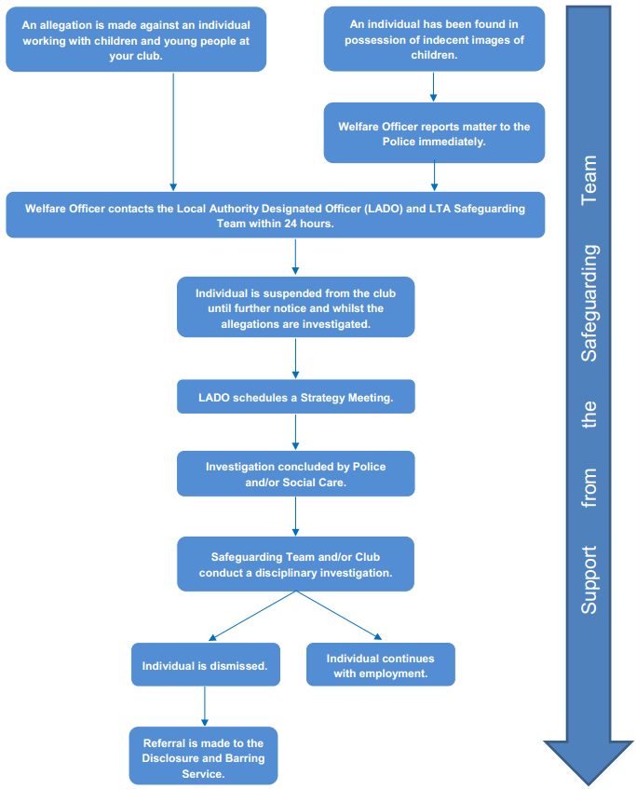

Appendix iii

Safeguarding Concern Form (SCF)

Please use BLACK ink only

Please complete within 24 hours and send to the Safeguarding Team within 48 hours
Date of concern: |  | Date form created:

Details of the person who is raising the concern
Name
Date of Birth
Name of venue
Role at venue
Telephone
Email

Details of the person you are concerned about
Name
Role in tennis (please circle) | Child  Adult at Risk  Coach  Official  Welfare Officer  Volunteer  Parent  Club Committee Member  Other (please detail):
Date of Birth
Telephone
Email
Address

Details of the parent/carers
Name(s)
Telephone
Email
Address

Details of the person alleged to have caused harm
Name
Role in tennis (please circle) | Child  Adult at Risk  Coach  Official  Welfare Officer  Volunteer  Parent  Club Committee Member  Other (please detail)
Date of Birth
Telephone
Email
Address
Do they work/volunteer anywhere else? (please circle) | Yes No
If yes, please detail

Confidentiality

If the allegation is against a member of staff or volunteer that person should not be informed of the concern until advice has been sought from the LTA/ESR Safeguarding Team.
Have the parents/carers or adult at risk been informed of the concern? (please circle) | Yes No
If not, please state why
(If you feel that informing the parents or carers about the concern will put the child or yourself at risk, you should not inform the parent or carer but will need to document here why.
Adults at risk need to be informed of your concerns).

When were the parents/carers or adult at risk informed of the concern? | (DD/MM/YYYY)  (Hr/Mins)
What was the response of the parent/carer or adult at risk?
Have the parents/carers or adult at risk given consent to share information? (please circle) | Yes No
If not, what was the reason?

Details of the concern
Facts
e.g. the child had a bruise on their right hand (please link any injuries to the Body Map attached as an appendix)
Opinions
e.g. I believe in my position as a tennis coach that the adult at risk is being pushed beyond their ability and this is causing injuries such as…
Hearsay
e.g. you overhear the child talking to their friend saying they are scared

Actions
What has been done about the concern?
Who has been informed about the concern? (please circle) | Role | Date contacted
Who has been informed about the concern? (please circle) | Welfare Officer  LTA/ESR Safeguarding Team  Police  Children’s Services  Adult’s Services  Local Authority Designated Officer  Other (please detail):
When were they contacted?
What was the name of the person(s) you spoke to?
What did they say?
What other actions (if any) have been taken?

Welfare Officer / Referee (if at competition)
When were you made aware of the concern?
Who have you informed about the concern? (please circle) | Role | Date contacted
Who have you informed about the concern? (please circle) | LTA/ESR Safeguarding Team  Police  Children’s Services  Adult’s Services  Local Authority Designated Officer  Other (please detail)
When were they contacted?
What was the name of the person(s) you spoke to?
What did they say?
What other actions (if any) have you taken?

Safeguarding Team contact details
T: 0208 487 7000
E: Safeguarding@LTA.org.uk

If you are concerned about a child, young person or adult at risk and believe them to be at immediate risk of harm please call the police on 999.

Appendix to form – Body Map
Record any physical injuries or marks you notice on the body map. Place a mark where the injury is and then a line out to written text describing the nature of the injury.
Care should be given to:
- Specify the location, e.g. right elbow
- describe the injury, e.g. large purple/red bruise etc.
- give the approximate size of the injury by relating to objects of a standardised size, such as British coins
- sign your name and date the injury was recorded.

Example: Open wound above right eyebrow which was bleeding. Approximately the size of a 10p coin. John Doe, 01/01/2014.

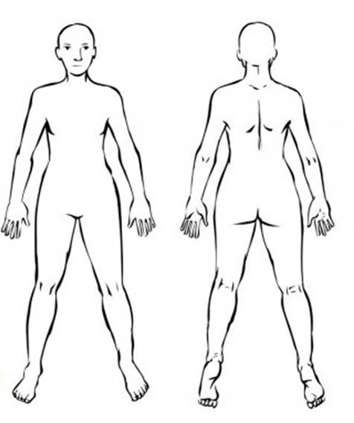

Appendix iv

Additional Support

Anyone who has been subject to abuse (including bullying), can get guidance and support from a number of organisations. These include:

Organsation | Website | Contact number
ChildLine | www.childline.org.uk | 0800 11 11
National Association for people Abused in Childhood (NAPAC) | www.napac.org.uk | 0800 085 3330 / 0808 801 0331
National Society for the Prevention of Cruelty to Children (NSPCC) | www.nspcc.org.uk | 0808 800 5000
Action on Elder Abuse (AEA) | www.elderabuse.org.uk | 0808 808 8141
Victim Support | www.victimsupport.org.uk | 0845 30 30 900
National Domestic Abuse Helpline | www.nationaldomesticviolencehelpline.org.uk | 0808 2000 247
Broken Rainbow | www.broken-rainbow.org.uk | 0300 999 5428
This is Abuse | www.thisisabuse.co.uk
Child Exploitation and Online Protection Centre (CEOP) | www.ceop-police.uk
Internet Watch Foundation | www.iwf.org.uk
UK Safer Internet Centre | www.saferinternet.org.uk | 0844 381 4772

The Management Committee
24 April 2023

