LLTSC Squash – Box Leagues
The Leamington box leagues are hosted on the Squash Levels website – a brilliant new creation that allows players of all levels the opportunity to track their progress, follow friends/rivals and generally feel more connected within the squash community.
To view the Leamington Boxes, visit www.squashlevels.com/boxes.php?clubid=477
To participate in these boxes, you must have created an account. You can create an account for free but access to all the extra features past your initial 1-month trial period requires a small subscription fee (not required to participate in the Leamington Boxes). Once you have done this, please let Jason know and he will include you in the next round of matches.
The responsibility to organise box league matches is on the players involved. A suggestion to facilitate conversation between the players and help with the organisation of matches is for one player from the group to create a WhatsApp group at the start of the period. Contact numbers are available via the Court Booking system membership list. If you can’t find what you are looking for on there, please speak to Jason who will be more than willing to help.
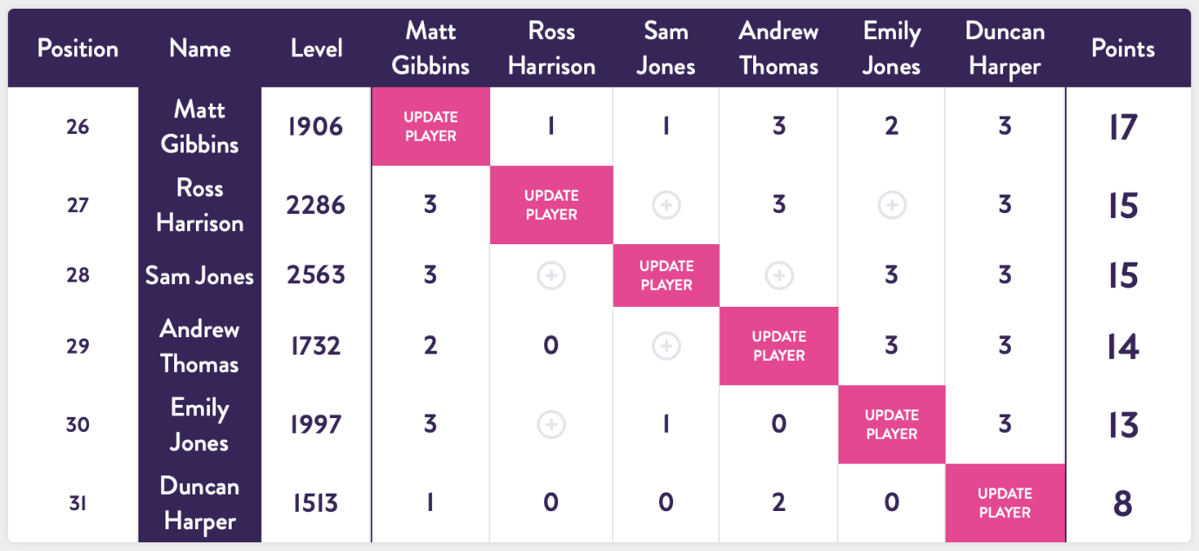
Once you have logged in to your account, your view of the leagues will look like this;

To add a score, you need to click on the appropriate plus sign.

If Ross Harrison had played Emily Jones, Ross should click on this icon to update the league table.

That link will take him to the following screen:
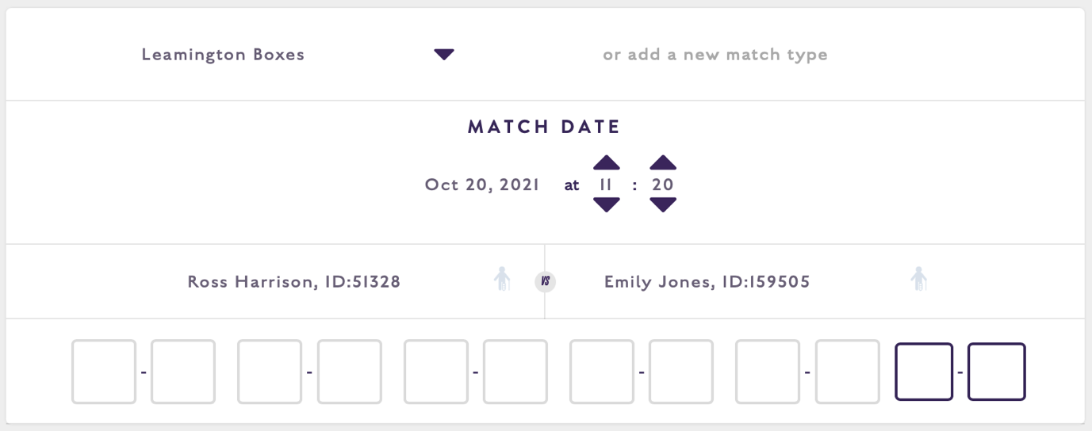

When entering the score, please make sure of the following things:
- Check the match type is Leamington Boxes
- Adjust date/time accordingly
- Enter all game scores
- Overall match score will be displayed. You do not need to add any bonus points, these are added automatically on the league table when you submit the score.
Bonus points added are as follows:
- 1 point each for participating in the match
- 1 point per game won
- 1 point for winning the match
Therefore, a 3-1 match score would equate to a 5-2 in points respectively
If, for whatever reason, a player does not turn up for a match and the players are unable to arrange another time before the league end date, the player can claim a walkover. When entering the match result, the player claiming the walkover should click on the icon located to the right of the player details. Again, match score and bonus points will be updated automatically once the result is submitted. It will be recorded as 4-0 in points to the player claiming the walkover. Squash level scores will not be affected.
At the end of the league period, the boxes will be processed, and players will move around as follows:
Assuming 6 players in total:
1st place in the box – up 2 boxes 5th place in the box – down 1 box
2nd place in the box – up 1 box 6th place in the box – down 2 boxes
Please bear in mind, this movement will be affected by players being added or removed from boxes.

Play Hard, Play Fair, Enjoy playing!

